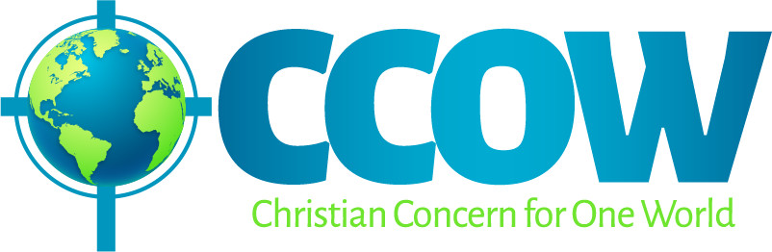
Some basic facts and figures
What’s the difference between a refugee, an asylum seeker and a migrant?
Refugees are people fleeing conflict or persecution. The 1951 United Nations Refugee Convention defines a refugee as a person who ‘owing to a well-founded fear of being persecuted for reasons of race, religion, nationality, membership of a particular social group, or political opinion, is outside the country of his nationality, and is unable to or, owing to such fear, is unwilling to avail himself of the protection of that country…’.
An asylum seeker is someone who has lodged an application for protection on the basis of the UN Refugee Convention or Article 3 of the European Convention on Human Rights.
An asylum seeker has the right to stay in the country while his or her application is dealt with. If the application is accepted, i.e. the authorities believe that the person would be at risk if returned to their home country, he or she is given refugee status. Refugees are allowed to stay long-term or indefinitely. Those whose asylum applications are refused must leave the country, unless they wish to appeal the decision or there are legitimate reasons why they cannot yet return home.
A migrant is simply any person who has moved to another country. Migrants have different reasons for migrating, including persecution, conflict and seeking work. They may or may not have a legal right to reside in the new country.
How many refugees are there worldwide?
- There are almost 80 million people worldwide who are forcibly displaced. Most of these stay within the borders of their country of origin and are known as “internally displaced people”.
- The current worldwide total number of “refugees”, who have fled into another country, is 26 million.
- The majority of refugees do not go further than their neighbouring country. 73% of the world’s refugees live in countries neighbouring their countries of origin and 85% are hosted in developing countries. The 5 countries which are hosting the most refugees are: Turkey (3.6 million), Colombia (1.8 million), Pakistan (1.4 million), Uganda (1.4 million) and Germany (1.1 million).
- The five countries from which most refugees currently come (68% of the worldwide total) are: Syria, Venezuela, Afghanistan, South Sudan and Myanmar.
How many refugees are there in the UK?
The latest UN statistics, for the end of 2016, record that in the UK there are a total of 119,000 refugees and 47,000 asylum seekers (whose cases are still pending).
What about Syrian refugees?
In September 2015 the UK government made a commitment to resettle 20,000 Syrian refugees over 5 years and established the Vulnerable Person Resettlement Programme, through which refugees would be brought to the UK directly out of UNHCR camps near Syria. By March 2021 20,319 people had come to the UK through this scheme .

http://www.unhcr.org/uk/refugees.html
http://www.unhcr.org/4ca34be29.pdf
http://www.echr.coe.int/Documents/Convention_ENG.pdf
See also: https://www.redcross.org.uk/stories/migration-and-displacement/refugees-and-asylum-seekers/six-things-you-need-to-know-about-refugees-and-asylum-seekers , “Refugees, Asylum Seekers & Migrants – Welcoming the Stranger” by Churches Together in the Merseyside Region: https://liverpooljp.files.wordpress.com/2018/01/aguide-welcomethestranger.pdf , and https://www.refugeecouncil.org.uk/glossary
All figures from: http://www.unhcr.org/uk/figures-at-a-glance.html
https://www.unhcr.org/uk/statistics/country/5a8ee0387/unhcr-statistical-yearbook-2016-16th-edition.html?query=unhcr-statistical-yearbook
https://www.gov.uk/government/publications/uk-resettlement-schemes-factsheet-march-2021/vulnerable-persons-and-vulnerable-childrens-resettlement-schemes-factsheet-march-2021

