Into Deep and Turbulent Waters
a service of prayer and holy communion for refugees

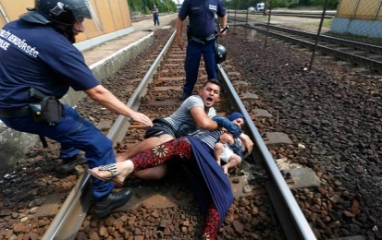
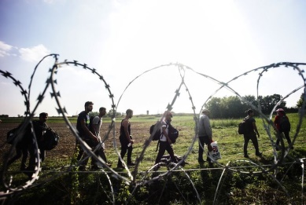
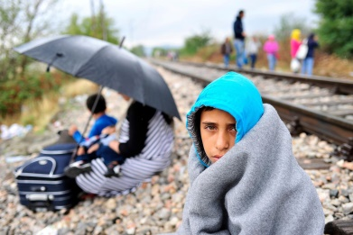
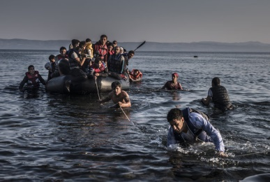
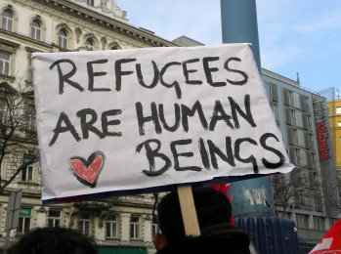

Almighty God,
you have set before us
numerous stories of prophets and sages
that at one time were forced to flee from their homes
in order to build your kingdom in this world.
Abraham, Sarah, Ruth and Moses
were all refugees for your name’s sake.
Help us to see
in the plight of immigrants and refugees,
an image of your Son, Jesus Christ,
the One, who like millions today,
had no place to lay his head,
and who felt unwelcome in his homeland.
Knowing that we often turn away
from the Christ present in one another,
we ask you, O God,
to open our minds and hearts
to the challenge brought by the current refugee crisis,
and to help us welcome the stranger in our midst
with radical love and hospitality.
Through Jesus Christ our Lord,
who lives and reigns with you
and the Holy Spirit,
one God, now and forever. Amen.
The Greeting
We meet in the presence of God
who knows our needs,
hears our cries,
feels our pain,
and heals our wounds.

The Gathering
Lord, we are your gathered people, come together to be one with refugees, asylum seekers and displaced people whose lives have been dislocated by war, famine and injustice. By our presence here we express our solidarity with them in their search for a new life, a new home, a new promise.
Lord, clear our eyes that we may see the suffering of the refugee.
Open our ears that we may hear the cries of those deep in despair.
Release our feet that we may walk on paths of comfort and peace.
Unloose our tongues that we might speak your words of hope and love.
Give us open hearts that we may offer hospitality to strangers in our midst.
The Confession
During his ministry, Jesus walked from village to village preaching the forgiveness of sins, and healing broken lives and broken communities. Let us confess our sins knowing that Christ continues to move amongst us and is ever ready to forgive our sins and call us into new life.
Most merciful God,
Father of our Lord Jesus Christ,
we confess that we have sinned
in thought, word and deed.
We have not loved you with our whole heart.
We have not loved our neighbours as ourselves.
In your mercy
forgive what we have been,
help us to amend what we are,
and direct what we shall be;
that we may do justly,
love mercy,
and walk humbly with you, our God.
Amen.
The Absolution
May God who loved the world so much
that he sent his Son to be our Saviour
forgive you your sins
and make you holy to serve him in the world,
through Jesus Christ our Lord.
Amen.

Let us pray.
We keep a time of silent prayer.
The Collect
Heavenly Father,
you are the source of all goodness, generosity and love.
We thank you for opening the hearts of many
to those who are fleeing for their lives.
Help us now to open our arms in welcome,
and reach out our hands in support.
That the desperate may find new hope,
and lives torn apart be restored.
We ask this in the name of Jesus Christ Your Son, Our Lord,
who fled persecution at His birth
and at His last triumphed over death.
Amen.

The Liturgy of the Word
First Reading: Leviticus 19:33-34
When an alien resides with you in your land, you shall not oppress the alien. The alien who resides with you shall be to you as the citizen among you; you shall love the alien as yourself, for you were aliens in the land of Egypt: I am the Lord your God.
This is the word of the Lord.
Thanks be to God.
Second Reading: Romans 12:9-21
Let love be genuine; hate what is evil, hold fast to what is good; love one another with mutual affection; outdo one another in showing honour. Do not lag in zeal, be ardent in spirit, serve the Lord. Rejoice in hope, be patient in suffering, persevere in prayer. Contribute to the needs of the saints; extend hospitality to strangers.
Bless those who persecute you; bless and do not curse them. Rejoice with those who rejoice, weep with those who weep. Live in harmony with one another; do not be haughty, but associate with the lowly; do not claim to be wiser than you are. Do not repay anyone evil for evil, but take thought for what is noble in the sight of all. If it is possible, so far as it depends on you, live peaceably with all. Beloved, never avenge yourselves, but leave room for the wrath of God; for it is written, ‘Vengeance is mine, I will repay, says the Lord.’ No, ‘if your enemies are hungry, feed them; if they are thirsty, give them something to drink; for by doing this you will heap burning coals on their heads.’ Do not be overcome by evil, but overcome evil with good.
This is the word of the Lord.
Thanks be to God.
Gospel Reading: Matthew 5:38-48
Hear the Gospel of our Lord Jesus Christ according to St Matthew.
Glory to you, O Lord.
‘You have heard that it was said, “An eye for an eye and a tooth for a tooth.” But I say to you, Do not resist an evildoer. But if anyone strikes you on the right cheek, turn the other also; and if anyone wants to sue you and take your coat, give your cloak as well; and if anyone forces you to go one mile, go also the second mile. Give to everyone who begs from you, and do not refuse anyone who wants to borrow from you.
‘You have heard that it was said, “You shall love your neighbour and hate your enemy.” But I say to you, Love your enemies and pray for those who persecute you, so that you may be children of your Father in heaven; for he makes his sun rise on the evil and on the good, and sends rain on the righteous and on the unrighteous. For if you love those who love you, what reward do you have? Do not even the tax-collectors do the same? And if you greet only your brothers and sisters, what more are you doing than others? Do not even the Gentiles do the same? Be perfect, therefore, as your heavenly Father is perfect.
This is the Gospel of the Lord.
Praise to you, O Christ.
Reflection
Affirmation of Faith
We say together in faith:
Holy, holy, holy
is the Lord God almighty,
who was, and is, and is to come.
We believe in God the Father,
who created all things:
for by his will they were created
and have their being.
We believe in God the Son,
who was slain:
for with his blood,
he purchased us for God,
from every tribe and language,
from every people and nation.
We believe in God the Holy Spirit:
the Spirit and the Bride say, ‘Come!’
Even so come, Lord Jesus!
cf Revelation 4.8, 11; 5.9; 22.17, 20
Amen.

Prayer Stations
- Escape: Prayers for those fleeing violence, persecution and war
- Displacement: Prayers for those living in refugee camps
- Refuge: Prayers for those seeking to build new a home
- Peace: Prayers for healing in war-torn lands
Prayers of Intercession
Grant, Almighty God, that as we join together in prayer, we remember your word, which bids us to “love the stranger who dwells among you for you were strangers in the Land of Egypt.”
God of the poor,
help us to welcome the strangers in our midst.
We confess that the scale and the complexity of this refugee crisis leaves us feeling overwhelmed. We are scared to admit that there will be no shortcuts or simple solutions. Have mercy on us. In our uncertainty, we pray for the moral courage to discern truth from falsehood, to challenge prejudice with openness, and to face the suffering of others with the compassion of Jesus Christ.
God of the poor,
help us to welcome the strangers in our midst.
We pray for all those who flee oppression and persecution in their homeland only to find desperation and loneliness in a foreign land. We pray for all refugees living in camps and for all who have made it to the shores of Europe, especially those washed up on crowded islands of Greece.
God of the poor,
help us to welcome the strangers in our midst.
We pray for all European states struggling to accommodate the constant flow of human need. We pray for all who stand against the kind of fear and prejudice which provokes aggression and scapegoating violence against the vulnerable. We pray for strong leadership in guiding the nations of Europe to welcome and integrate our brothers and sisters from across the globe.
God of the poor,
help us to welcome the strangers in our midst.
We pray for churches, as well as other faith-based and secular organizations who work tirelessly to support the strangers in our midst. We pray especially for the international work of Christian Aid, Tearfund, and the United Society; and more locally, for the work of Asylum Welcome in Oxford and the Reading Refugee Support Group.
God of the poor,
help us to welcome the strangers in our midst.
We pray that the communities of which we are a part of will continue to embrace and support disenfranchised persons, and that our ministry may serve as an inspiration for other parishes looking to serve those in need.
God of the poor,
help us to welcome the strangers in our midst.
We pray for all those whom it would be easy for us to neglect. We pray for the homeless and the poor, the old and the sick. We pray for those with no home, and those who find themselves strangers in a foreign land.
God of the poor,
help us to welcome the strangers in our midst.
We pray for those who have been victims of any kind of human trafficking, and for human traffickers themselves, asking that you would break the bonds of oppression, create within them new hearts and spirits, and remove their hearts of stone.
God of the poor,
help us to welcome the strangers in our midst.
Comfort and heal all those who suffer in body, mind, or spirit; give them courage and hope in their troubles, and bring them the joy of your salvation. We remember especially those known to us:
[please add your own petitions, aloud or in silence]
God of the poor,
help us to welcome the strangers in our midst.
We remember the thousands of men, women and children who have died or gone missing in their desperate attempts to cross the Mediterranean and Aegean seas last year alone. We pray for all those who grieve the loss of loved ones at this time.
God of the poor,
help us to welcome the strangers in our midst.
Almighty God, make us instruments of your peace. Help us to create welcoming and hospitable communities in your kingdom. In all times of fear and dread, grant that we may so cast our burdens upon you, that you may bear us on the holy wings of the Spirit to the stronghold of your peace. We ask all this in the name of Jesus Christ our Lord, in whom we live and move and have our being. Amen.
The Liturgy of the Sacrament
The Peace
God calls us to peace:
in God’s justice is our peace.
Christ calls us to be God’s people:
in Christ is our peace.
cf Ephesians 2.14,15
The peace of the Lord be always with you
and also with you.
Let us offer one another a sign of peace.
We exchange a sign of peace.
Preparation of the Table
Taking of the Bread and Wine
Our gifts are gathered and presented. The table is prepared and bread and wine are placed upon it.
The presiding priest takes the bread and wine, saying:
Blessed be God,
who feeds the hungry,
who raises the poor,
who fills our praise.
Blessed be God for ever.
The Eucharistic Prayer
The Lord is here.
His Spirit is with us.
Lift up your hearts.
We lift them to the Lord.
Let us give thanks to the Lord our God.
It is right to give thanks and praise.
Preface for Refugees
It is right, and a good and joyful thing, always and everywhere to give you thanks, Father Almighty, Creator of heaven and earth, through your dearly beloved Son Jesus Christ our Lord.
Like millions of people today, your Son was a refugee, a migrant travelling on foot and by boat to foreign lands. He relied on the hospitality of strangers, and was met with scepticism, doubt and eventually, death.
But he did not die in vain, but instead died for us that we may live anew. Through his life and sacrifice, we now understand that it is through loving that we are loved, and it is through welcoming the stranger in our midst that we begin to fully welcome the stranger that is our true self.
We bless you for your mercy
and join with saints and angels
for ever praising you and saying:
Holy, holy, holy Lord,
God of power and might,
heaven and earth are full of your glory.
Hosanna in the highest.
Blessed is he who comes in the name of the Lord.
Hosanna in the highest.
We praise and bless you, loving Father,
through Jesus Christ, our Lord;
and as we obey his command,
send your Holy Spirit,
that broken bread and wine outpoured
may be for us the body and blood of your dear Son.

On the night before he died
he had supper with his friends
and, taking bread, he praised you.
He broke the bread, gave it to them and said:
Take, eat; this is my body which is given for you;
do this in remembrance of me.
When supper was ended he took the cup of wine.
Again he praised you, gave it to them and said:
Drink this, all of you;
this is my blood of the new covenant,
which is shed for you and for many for the forgiveness of sins.
Do this, as often as you drink it, in remembrance of me.
So, Father, we remember all that Jesus did,
in him we plead with confidence his sacrifice
made once for all upon the cross.
Bringing before you the bread of life and cup of salvation,
we proclaim his death and resurrection
until he comes in glory.
Praise to you, Lord Jesus:
Dying you destroyed our death,
rising you restored our life:
Lord Jesus, come in glory.
Lord of all life,
help us to work together for that day
when your kingdom comes
and justice and mercy will be seen in all the earth.
Look with favour on your people,
gather us in your loving arms
and bring us with all the saints
to feast at your table in heaven.
Through Christ, and with Christ, and in Christ,
in the unity of the Holy Spirit,
all honour and glory are yours, O loving Father,
for ever and ever. Amen.
The Lord’s Prayer
As our Saviour Christ has commanded and taught us,
we are bold to say:
Our Father, who art in heaven,
hallowed be thy name;
thy kingdom come;
thy will be done,
on earth as it is in heaven.
Give us this day our daily bread.
And forgive us our trespasses,
as we forgive those who trespass against us.
And lead us not into temptation;
but deliver us from evil.
For thine is the kingdom,
the power and the glory,
for ever and ever.
Amen.
Breaking of Bread
The presiding priest breaks the bread.
We break this bread
to share in the body of Christ.
Though we are many, we are one body,
because we all share in one bread.
Giving of Communion
Jesus is the Lamb of God
who takes away the sin of the world.
Blessed are those who are called to his supper.
Lord, I am not worthy to receive you,
but only say the word, and I shall be healed.
We go forward to receive communion.
Prayers after Communion
Silence is kept.
Great God, you are one God,
and you bring together what is scattered
and mend what is broken.
Have compassion on those that suffer
in solitude and abandonment.
Save the victims of hunger, oppression, and persecution
from the terrors and torture of war and violence.
Unite us with the scattered peoples of the earth
that we may be one family of your children.
Bind up all our wounds
and heal us in spirit,
that we may be renewed as disciples of Jesus Christ,
our Master and Saviour.

The Dismissal
Christ, send us out into the world
to love one another as you love us.
And to welcome the strangers in our midst
as you have so boldly welcomed us.
Amen.

Go in peace to love and serve the Lord.
In the name of Christ. Amen.

All liturgies (unless marked) are authorized by the Church of England General Synod.
© The Archbishops’ Council of the Church of England, 2000.

Adapted from St Paul's Within the Walls, Episcopal Church in Rome, “Resources to Celebrate World Refugee Day,” available at http://jnrc.it/wp-content/uploads/2015/06/World_Refugee_Bulletin_Resource-1-1.pdf.
Adapted from Loreto Conroy, “Liturgy: Offering Hospitality to Refugees” (2003), available at http://www2.crcna.org/site_uploads/uploads/crwrc/resources/refugee/crwrc_RefugeeKitLiturgy.pdf.
St Paul's Within the Walls, “Resources to Celebrate World Refugee Day.”
Church of England, “Topical Prayers: Prayer for the Refugee Crisis,” available at https://www.churchofengland.org/prayer-worship/topical-prayers/a-prayer-for-the-refugee-crisis.aspx.
Adapted from St Paul's Within the Walls, “Resources to Celebrate World Refugee Day.”
St Paul's Within the Walls, “Resources to Celebrate World Refugee Day.”
Adapted from St Paul's Within the Walls, “Resources to Celebrate World Refugee Day” and a closing prayer from CW.
St Paul's Within the Walls, “Resources to Celebrate World Refugee Day.”

