Additional Materials for Prayer Stations
CCOW Time of Prayer and Reflection

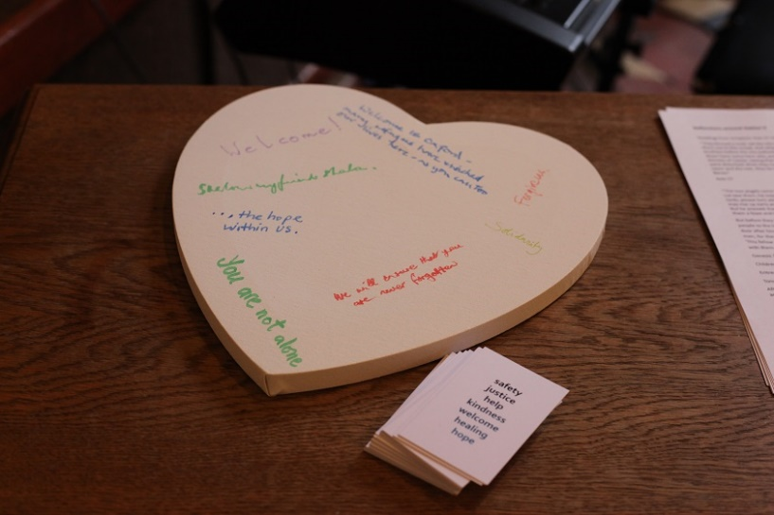
‘Welcome’
We added a heart-shaped canvas (available from craft stores … you could also simply cut a heart from a large piece of white card) on which people were able to write messages of welcome. This could then be set up in the church, as a reminder to the congregation and a sign of welcome to any new refugees who might come.

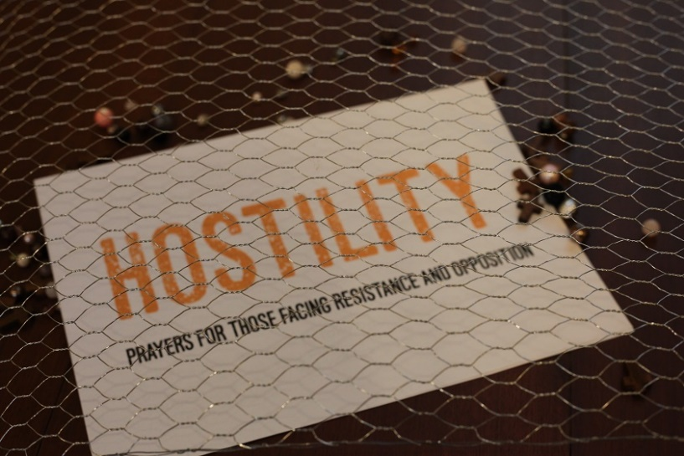
‘Hostility’
We used a piece of wire garden fencing, stretched over a table, under which were the prayer station sign and a variety of beads (larger work better than smaller) representing the precious nature of each person created in the image of God.

Beside the installation was a heart-shaped cardboard box (available from craft stores – or you could borrow ours, or just use an ordinary box), into which people deposited their bead.
Also beside the installation we had a variety of materials sharing stories of people who had experienced hostility in the countries to which they had fled … and materials from campaigns that are seeking to draw attention to – and to mitigate - difficulties that asylum seekers and refugees face in the UK and elsewhere.

